Exhibitor Registration Instructions for the 2019 GASSA/SSASC GA SC Southeastern Self Storage Conference and Tradeshow
To Register Yourself (1 person)
- Go to Exhibitor registration homepage at: http://www.ciclt.net/sn/events/e_signup.aspx?ClientCode=gfvga&E_ID=500397&RegType=ATT
- It will ask you to enter your email address or the email address of the person you wish to register, and then click the submit button next to the sentence that describes what you wish to do. IMPORTANT: Choose that you are registering only yourself clicking SUBMIT.
  - This is a new system, so everyone will first need to create an account before they are registered.
- Click the NEW REGISTRANT button to add yourself to the system.
- Enter the requested information in the text boxes (Please note: Required format for phone is 123.456.1234) and then click the submit button.
- Once you make it to the conference registration page, you will be required to input your contact info, membership info, and choose registration options.
- Please be sure to choose the correct MEMBER/NON MEMBER rate for your registration fees.
- We require you list your top 2-3 competitors for placement reasons. If you feel this question does not apply to you, please enter “None” in that field.
- If you plan to attend Topgolf on Sunday, first indicate the number of attendees (just 1 for yourself) and then list the names.
- Click “Calculate Total” to see the amount of total payment due.
- Click Submit. You should be taken to payment page if you opted to pay by credit card, or a confirmation page if you are paying with a check. You will receive a confirmation email as well.

To Register Multiple People
- Go to Exhibitor registration homepage at: http://www.ciclt.net/sn/events/e_signup.aspx?ClientCode=gfvga&E_ID=500397&RegType=ATT
- It will ask you to enter your email address or the email address of the person you wish to register, and then click the submit button next to the sentence that describes what you wish to do. IMPORTANT: Choose that you are registering multiple people by clicking SUBMIT.
  - This is a new system, so everyone will first need to create an account before they are registered.
  - Each person will have to be added to the system. First add them to the system, and then select and add them to the registration. Be sure to add yourself to the form!

- Click Register multiple people for this event.
- Click the NEW REGISTRANT button to add yourself and others to the system.
- Enter the requested information in the text boxes (Please note: Required format for phone is 123.456.1234) and then click the submit button. 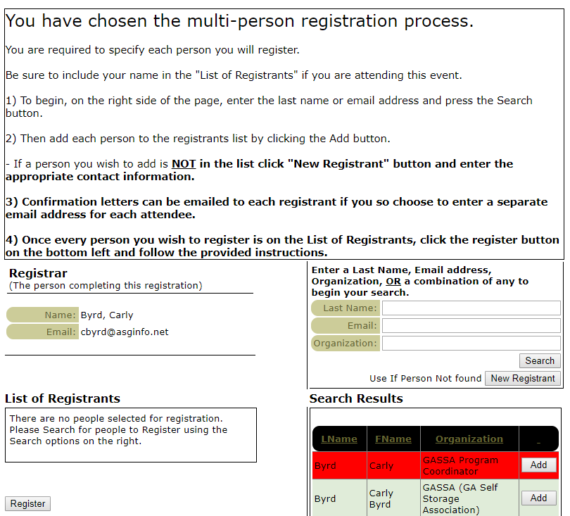
- Once you make it to the conference registration page, you will be required to input your contact info, membership info, and choose registration options.
- Please be sure to choose the correct MEMBER/NON MEMBER rate for your registration fees.
- We require you list your top 2-3 competitors for placement reasons. If you feel this question does not apply to you, please enter “None” in that field.
- If you plan to attend Topgolf on Sunday, first indicate the number of attendees (just 1 for yourself) and then list the name(s).
- Click “Calculate Total” to see the amount of total payment due.
- Click Submit. You should be taken to payment page if you opted to pay by credit card, or a confirmation page if you are paying with a check. You will receive a confirmation email as well.

